***Social Media Sentiment Analysis Report***

***Prepared***

***by***

***AMAN RAJBHAR***

*August 2024*

# Introduction

This report provides a deep dive into social media sentiment analysis across major platforms like Instagram, Twitter, and Facebook. The analysis uncovers patterns in user emotions, engagement metrics, and regional trends, offering actionable insights for boosting brand engagement and positive sentiment.

# Data Overview

|  |  |  |  |  |
| --- | --- | --- | --- | --- |
| **Text** | *User-generated content showcasing sentiments* |  | **Year** | *Year of the post* |
| **Sentiment** | *Categorized emotions* |  | **Month** | *Month of the post* |
| **Timestamp** | *Date and time information* |  | **Day** | *Day of the post* |
| **User** | *Unique identifiers of users contributing* |  | **Hour** | *Hour of the post* |
| **Platform** | *Social media platform where the content originated* |  |
| **Hashtags** | *Identifies trending topics and themes* |  |
| **Likes** | *Quantifies user engagement (likes)* |  |
| **Retweets** | *Reflects content popularity (retweets)* |  |
| **Country** | *Geographical origin of each post* |  |

# Data Visualization

The following section includes visual representations of the data analyzed during this project. Charts and graphs are used to illustrate sentiment distribution, user engagement levels, and platform-specific trends.

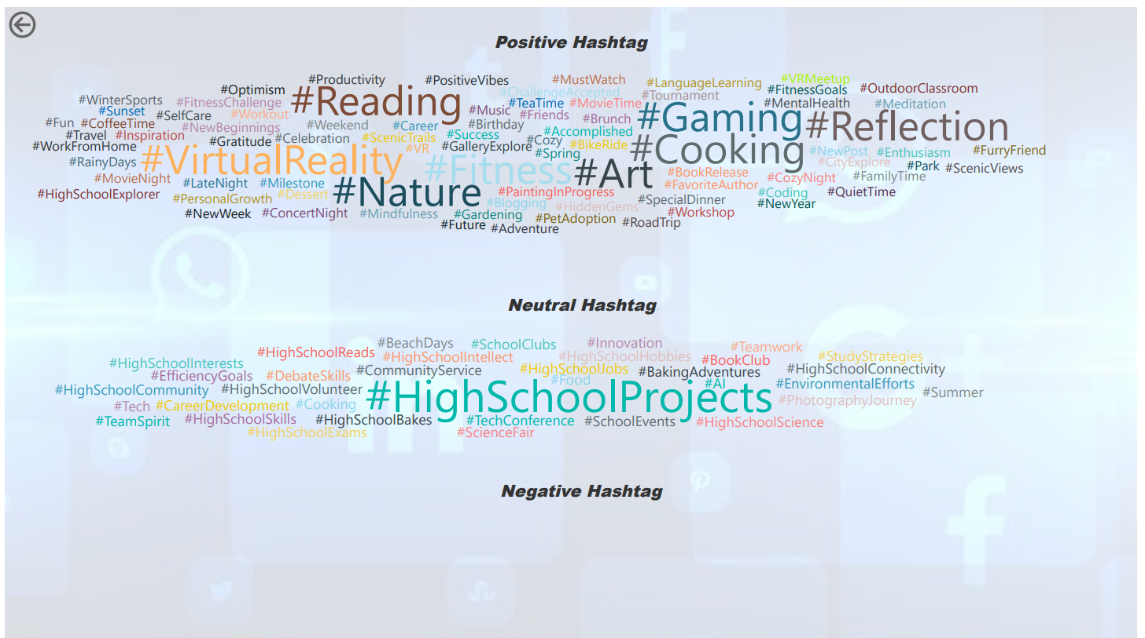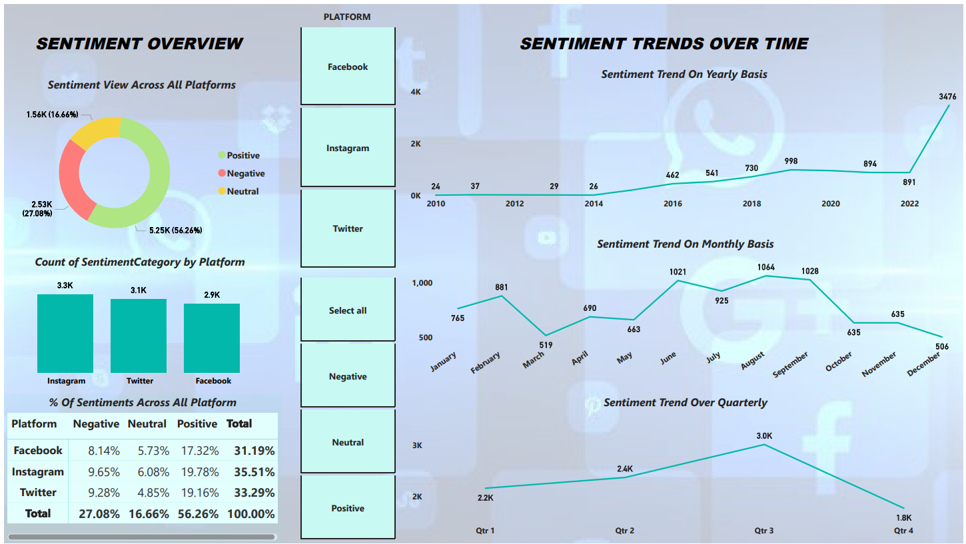

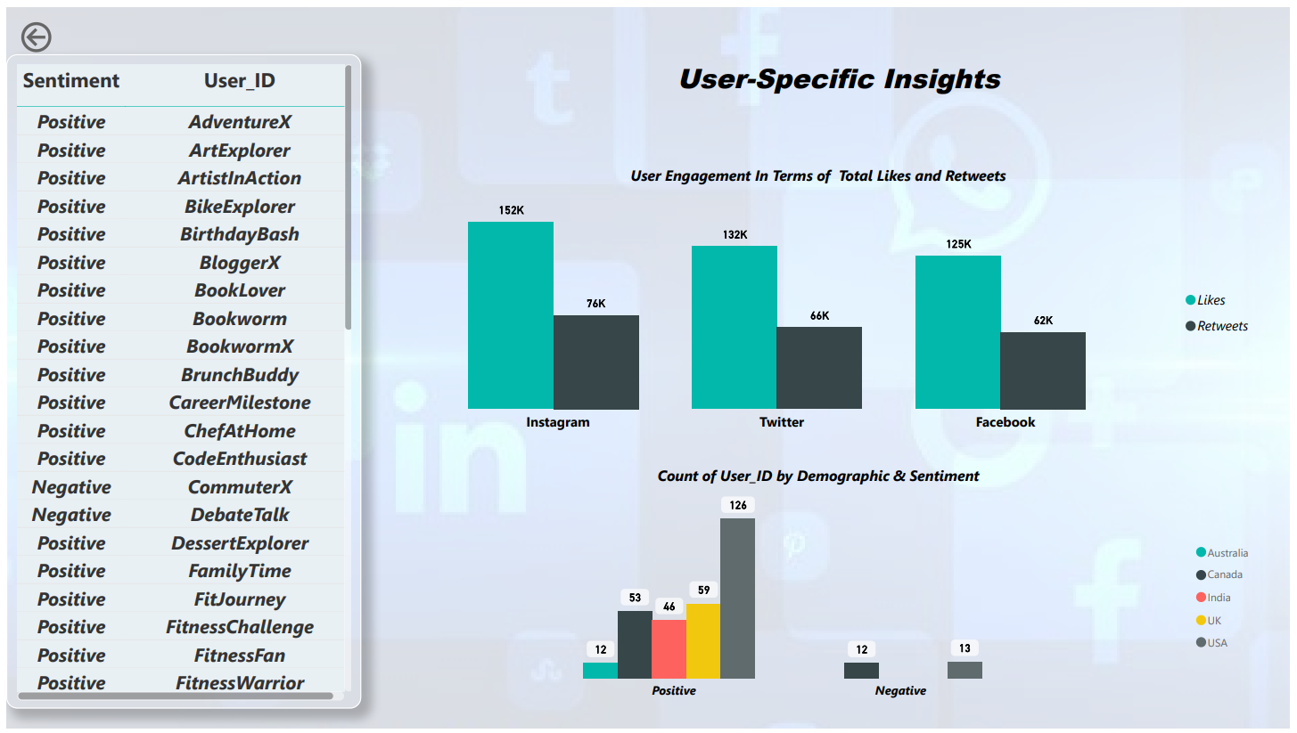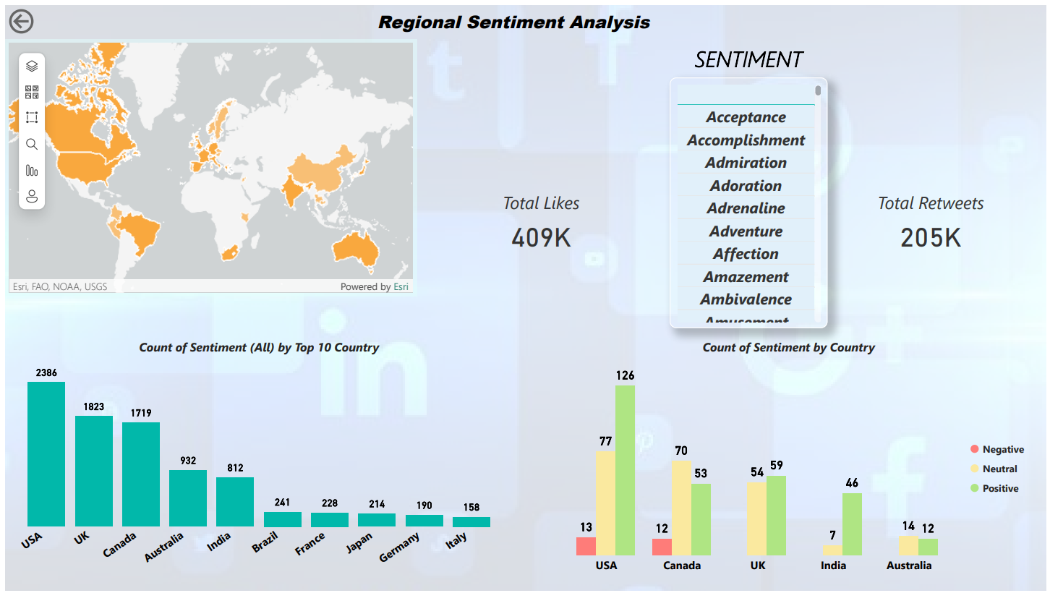

# 

# Key Findings & Insights

**Sentiment Distribution Across Platforms**

* **Positive Sentiment Dominates:** 56.26% of total sentiments are positive, with Instagram leading at 19.78%.
* **Platform Sentiment Breakdown:**
  + **Instagram:** Highest positivity (19.78%)
  + **Twitter & Facebook:** Strong but slightly lower positivity (around 17%)

**Quarterly and Monthly Sentiment Trends**

* **Quarterly Trends:** Positive sentiment peaks in Q3.
* **Monthly Insights:** March, June, and October show spikes in positive sentiment.

**Regional Sentiment Analysis**

* **Top Markets:** USA, UK, Canada, and Australia lead in sentiment volume.
* **Strong Positive Sentiment:** Notable in North American markets.

**User Engagement Metrics**

* **Instagram:** Highest engagement with 152K likes and 76K retweets.
* **High-Engagement Themes:** Fitness, productivity, and social interaction-related hashtags drive the most engagement.

***Recommendations***

**1. Focus on Positive Engagement**

* **Action:** Develop content strategies that promote positive emotions, particularly on Instagram.

**2. Address Negative Feedback**

* **Action:** Implement proactive customer service and PR strategies to mitigate negative sentiment.

**3. Localized Marketing Strategies**

* **Action:** Tailor campaigns to align with regional sentiment trends, focusing on North American markets.

**4. Leverage High-Engagement Themes**

* **Action:** Use popular hashtags related to fitness and productivity to increase user interaction and content visibility.

# Conclusion

By aligning with the insights and recommendations derived from this sentiment analysis, businesses can enhance their social media strategies, improve user engagement, and foster a stronger brand reputation. Consistent monitoring and adaptation to these trends are crucial for sustaining a positive online presence.

# Skills & Tools Used

Skills applied in this project include:

- Data Collection and Cleaning

- Sentiment Analysis

- Data Visualization(Power BI)

- Data Analysis Expressions (DAX)

- ChatGPT

**Contact Information**

Rajbharamankumar@gmail.com | [[linkedin.com/in/aman-rajbhar-a579a3270](https://www.linkedin.com/in/aman-rajbhar-a579a3270?lipi=urn%3Ali%3Apage%3Ad_flagship3_profile_view_base_contact_details%3BZ41NjqouRcS5syWTDDa6hg%3D%3D)] |